CIT 360

Reflection Journal

Spring 2016

Dan Hively



Week 1

The start of a new semester of class is always a stressful time for me. The process of getting things scheduled and everything lined up so that all of my assignments get completed is a huge chore. Working full time and juggling school and family is sometimes difficult. I can’t image what some of my class mates, many with small children go through. Sometimes I feel that I have the easier time of it. All my children are grown.

This class has an interesting approach. Most of the assignments that are to be completed are individual but in a group or team setting. The class uses Google Groups. There is one for the whole class and one for each team. We will be assigned a set of topics to work on for the first part of the semester and then a big team project for the last part of the semester. This class really uses the BYU Idaho learning model, especially Teach One Another.

*77 And I give unto you a commandment that you shall teach one another the doctrine of the kingdom.*

*78 Teach ye diligently and my grace shall attend you, that you may be instructed more perfectly in theory, in principle, in doctrine, in the law of the gospel, in all things that pertain unto the kingdom of God, that are expedient for you to understand;*

*Doctrine and Covenants 88:77-78*

Week 2

The class has a lot of content that I need to learn! The topics are pretty cool. Here is a list of them.

# Topics

1. Java Collections (one each of Map, List, Set, Tree) Addition, Removal, using Iterators.
2. Hibernate
3. JSON Serialization
4. HTTP URLConnection
5. JUnit Tests
6. Threads, Executors, Runnables, Handlers
7. Model View Controller Pattern
8. Application Controller Pattern
9. Client and Server Sockets
10. Use Case Diagram
11. Use Case Document
12. State Diagram
13. Sequence Diagram
14. Class Diagram
15. Activity Diagram

That is a lot of stuff!!



Week 3

Every week from now until we start working on our application will be devoted to learning the topics outlined for the course. I need to learn as fast as I can and as much as I can because there will always be something that gets in the way of school. That’s the way it usually goes for me and I’m sure I’m not alone. Our team has chosen to meet at 7 pm on Tuesday.

Week 4

Lots of work and lots of learning new things and new technique for object orientated work. It’s pretty interesting to me so I find it easier to study but I feel like I’m getting behind already. I may be a little late but I have started searching the Internet for examples and stuff.

Week 5

Our team is really rolling now. A really great group of people and fun to work with. My experience working in groups for school has not always been the best. I’m very pleased so far. I have had people in groups who were full time students, didn’t work and had no kids. I was always amazed when they said, “You mean you can’t meet at 10am? How come?”.

Week 6

Sometimes I feel so far behind I think I may never catch up. Starting to look more closely into some of the other topics. I’m particularly looking into some stuff about Hibernate ORM.

Week 7

We are going to try to build an application “Eagle Tracker”. We want to put together an app that can show where eagles are sighted and keep track of characteristics like size, age, color etc.

Week 8

Looking forward to working on the application. That will be proving the pudding I think. First we learn (teach) the topics and then we put it into a semi real world setting as a team and put it all together into a working application. It’s pretty neat.

Week 9

Working with people is sometimes difficult but my team is exceptional!

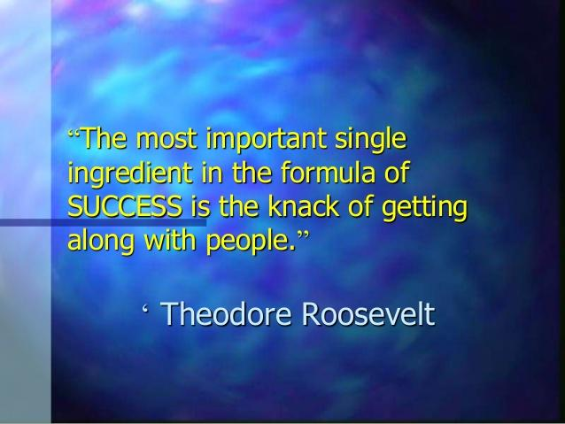

One of the interesting things about the BYU Idaho learning model is the emphasis on teaching one another. A great skill to learn especially in real life. I have not always been a fan!

Week 10

Github can be a fickle mistress! I have had to redo some of my stuff because of errors in git. I’m pretty sure I have it sorted now but very frustrating!

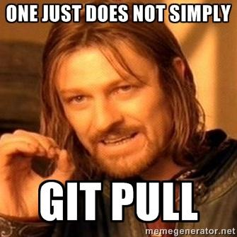

# Week 11

Putting the finishing touches on our application as much as we can. We didn’t get everything we had planned working but we still need to make a presentation. It’s the process we learned and implemented that counts I guess. Not necessarily the finished product. Turning in the application is such a relief and a giant weight off. Now I can work on some other things I’ve gotten further behind on.

# Week 12

The end of the semester and hurrying to get caught up from last minute tweaks to my portfolio. I didn’t get everything in it that I wanted but that’s what I have.

